MyCondo

A web/mobile Application

**A group assignment project for Software Engineering Methodologies (COMP 246)**

**Course at Centennial College Progress Campus.**

**Presented by: Directed by:**

**Barbara HOUNKPE (300769037) Khan Mohamed**

**Divya SHARMA (300991462)**

**Yueyang (Micheal) SUN (300933625)**

**Jasneet KAUR (300961578)**

# Table of contents

Table of contents 2

I. Problem Description 3

II. System Capabilities 3

III. Business Benefit 4

IV. Workflow 4

1. User authentication module (workflow) 4

2. Service module 6

2.1. Request a service workflow 6

2.2. Update a service request status workflow 9

2.3. Add comments on the request workflow 11

2.4. Rate the service workflow 13

3. View report workflow 15

V. Use case List 17

VI. Use case Diagrams 19

1. Authentication Module 19

2. Service Module 19

3. Reports Module 20

VII. Domain class Diagram 21

VIII. Gantt chart 22

# Problem Description

The Condominium Association of Toronto (CAT) is a newly established organization that aims to improve condominium living by providing services and resources for condo owners and residents. These include the easy access of information and services in Toronto condominiums.

Most of the condominium in this association are currently using the system called **frontdeskinc** which is only accessible to the security and the management to manage the building. This accessibility limit has becomes an ongoing issue withcommunications with management and other services.

In addition, there is a favoritism in certain services such as service requests. Therefore, CAT need a system that will include usability not only security and managements but also resident/Tenants, the owner and the superintendent to manage services. The system should be able to allow resident/tenant to request services, interact with management and other users. As a result, there will be an easy communication between the management and resident as well as the fair services in the building.

# System Capabilities

MyCondo system will be an integrated system including other subsystems and module. The main focus on this project will be the ability of MyCondo to have the capabilities below:

* User validation

Users will have a login and password that will give them access to the system.

* User Registration

Users will register themselves if they do not have any account with MyCondo app.

* Create a user

Management should be able to create a user and attribute an access level such as manager, resident/tenant, owner or superintendent.

* Manage User

Management should be able to update or delete a user or change access level of a user.

* Online service request

Residents/Tenants should be able to request services such request a problem to be fixed in their unit (water, HVAC issues) and rate the service at the end. Management or superintendent should be able to change state of the request, add a comment.

* Add Comments on the Service and Rate the Service

Users will Rate and add comments on the services if they want to.

* Update Service Request

Users will update the service request Status.

* Report to Manager

Manager should see the report throughout the day about MyCondo

# Business Benefit

After deployment, MyCondo will provide CAT, the following benefits:

* Provide mobile access to residents/tenants and owners as well as management to facilitate the easy access to services in the building,
* Save time in case of service providing and communication in the building
* Provide a fair service to all resident/tenants as well as the owners
* Long term money saving because of the reduction of the hours of some staff.
* Possibility for manager to be present on site not physically but through the app and be able to interact with the building operation and stay on top with the news.
* Improve to management and resident/tenants or owner collaborations or relations
* Monitor all activities in the building and have originals reports from residents/tenants and owners.

In this project, we will be focusing only on the **request Service** module

# Workflow

## User authentication module (workflow)

* **Description**

An existing MyCondo user will be prompt to enter username and password. The system will check the values of the password and username. If those values are wrong, the system will display wrong input and will ask the user to re-enter the username and password. In case the inputs are correct, the system will check the user type and return the appropriate page.

* **Steps**
  1. User will start the application,
  2. System will prompt user to enter username and password,
  3. User will input the login Information,
  4. System will verify the inputs
  5. If inputs are wrong, return to 2
  6. If input is true, system will check the user type
  7. System will send the Appropriate page
* **Workflow**



## Service module

### Request a service workflow

* **Description**

On The request service page, a user will click on request services. The system will send the request form to fill. The user will fill the information. System will check the inputs. If the inputs are wrong, the system will not validate the form and will send it back to the user to refill properly. If the result is correct, the system will process the inputs and notify the proper person bas on the classification of the request.

* **Steps**

1. User will start the application,
2. System will prompt user to enter login
   1. If user login successfully, go to step 3
   2. If login info wrong go back to step 2
3. User will ask for service.
4. System will send the request form to the user to fill
   1. If the form is valid go to step 5
   2. If the form is invalid, system will display message of required field and stay at 4
5. System will send a copy of the request to superintendent and management
6. System will save a copy of the request in the database

* **Workflow**



### Update a service request status workflow

* **Description**

Once a request is submitted, the manager superintendent are notified. The management the login in the app to see full details of the request. The management the take appropriate steps to work on the request. Therefore, the management will update the status of the service accordingly to the state of the work.

* **Steps**
  1. User will start the application,
  2. System will prompt user to enter login
  3. If user login successfully, go to step 3
  4. If login info wrong go back to step 2

1. User will select the service requested
2. User will change the status of the service from “Requested” to “Work in progress” and to “Completed” base on the evolution of the work
3. System update value of the status in database
4. System will notify the appropriate user of the status

* **Workflow**



### Add comments on the request workflow

* **Description**

Once the request is submitted, either the superintendent, the manager or the owner can enter and add a comment to the request. The system check if the comment text is not empty. If empty, ask user to enter value. If not empty, post the comment and notify all users involve. Save a copy in database.

* **Steps**

1. User will start the application,
2. System will prompt user to enter login
   1. If user login successfully, go to step 3
   2. If login info wrong go back to step 2
3. User will select the service requested
4. User will add a comment
5. System will check the value of the comment
   1. If the comment I empty, system will display message of invalid comment and stay at step 4
   2. If not empty, go to step 6
6. System will send a copy of the comment to superintendent and management
7. System will save a copy of the comment in the database
8. System will display comment posted successfully message

* **Workflow**



### Rate the service workflow

* **Description**

Once the request status is completed, the owner/tenants/resident will be prompt to rate the service. If user say no, the requested is archived and if yes, the system send the service rate page to the user. Once the user fill the necessary information, the system check if the entire form is filled properly. If no, the system ask user to complete the missing filled. If yes, the management and superintendent are notified and the info is saved in the database.

* **Steps**

1. User will start the application,

2. System will prompt user to enter login

* 1. If user login successfully, go to step 3
  2. If login info wrong go back to step 2

3. User will check the status of the request submitted

* 1. If status is completed g to step 4
  2. If status Is different from completed, user can have access to subsystem comment or exit application

4. System will ask user to rate the service

* 1. If user say yes go to step 5
  2. If user say no, archived the requested and save in database

5. System will send the rate form to the user to fill

* 1. If form is filled properly go to step 6
  2. If form missing mandatory field, go to 5

6. System send a copy of the rate to manager and superintendent an save a copy in database

**Workflow**

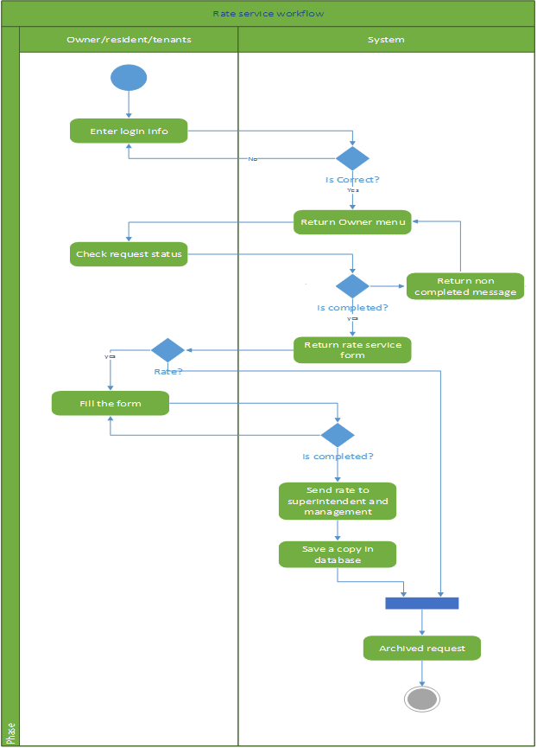

## View report workflow

* **Description**

Manager log in the app at the end of the day. Manager ask for a complete report. The system add all the request in one file and return to manager.

* **Steps**

1. Admin start application

2. Application request admin login

2.1 If login correct, go to 3

2.2 If incorrect, go to 2

3. Admin request a daily report

4. System put all the request throughout the day and send all in 1 file

* **Workflow**



# Use case List

|  |  |  |
| --- | --- | --- |
| **No** | **Use Cases** | **Users Roles/Actors** |
| 1 | Authentication | All Users |
| 2 | Request Service | Residents |
| 3 | Add Comment | Residents, Manager, Superintendent |
| 4 | Update service | Manager, Superintendent |
| 5 | Rate Service | Residents |
| 6 | View report | Manager |

|  |  |  |
| --- | --- | --- |
| Use Case Name: | View Service Request | |
| Scenario: | Display the service request | |
| Triggering Event: | Actor ask to display the current status of the service request | |
| Description: | A user involved in the request needs to view the details of the service request. | |
| Actor: | Staff, Management, Owner, Tenant | |
| Related Use Case: |  | |
| Stake Holders: | Staff, Management, Owner, Tenant | |
| Pre conditions: | The service request exist The user have authorization to view it | |
| Post conditions: | Display different status from the service request record according to user type | |
| Flow of Events: | Actor | System |
|  | 1.Service request to be viewed | 2.Check user clearance level 3. Display fields of the service request accordingly |
| Exceptions: | 1. If no service request exists, display error message 2. If user have no permission to make changes, display error message 3. If the database didn’t respond, prompt error message | |

|  |  |  |
| --- | --- | --- |
| Use Case Name: | Update Service Request | |
| Scenario: | Save changes to service request | |
| Triggering Event: | Staff/Manager asked to make changes to the service request | |
| Description: | Changes needed to be made to a request update. staff or manager will access the fields of the service request and save any changes they made back into the database. | |
| Actor: | Staff, Management | |
| Related Use Case: | Extend: Give feedback | |
| Stake Holders: | Staff, Management, Owner, Tenant | |
| Pre conditions: | The requested service request exist The user have authorization to edit it | |
| Post conditions: | Any changes made is saved onto the service request | |
| Flow of Events: | Actor | System |
|  | 1.Request to save new data into an existing service request | 2.Check user clearance level 3. save the data into database, replacing any old data |
| Exceptions: | 1. If no service request exists, display error message  2. If user have no permission to make changes, display error message  3. If failed to update database, prompt user to try again later | |

|  |  |  |
| --- | --- | --- |
| Use Case Name: | Give Feedback | |
| Scenario: | Save changes to the customer rating section of service request | |
| Triggering Event: | Completion of a customer request | |
| Description: | After the completion of a customer request, the customer can reply with rating and comment to the service. The customer replies are then updated to the service request as well as the staff’s record. | |
| Actor: | Owner, Tenant | |
| Related Use Case: |  | |
| Stake Holders: | Staff, Management, Owner, Tenant | |
| Pre conditions: | The requested service request has been marked ‘done’ The user fill in the form for customer feed back | |
| Post conditions: | Changes saved onto the service request Ratings updated for the employees involved | |
| Flow of Events: | Actor | System |
|  | 1.send rating and comment | 2.Validate user feedback and change the comment accordingly(censorship) 3.update onto service request and employee record |
| Exceptions: | 1.if rating or comment is missing, the user is prompt to fill in all the boxes 3. If it failed to update service request or employee record for whatever reason, undo any changes made and tell the user that the rating/comment failed to update. | |

# Use case Diagrams

## Authentication Module



## Service Module



## Reports Module



# User Stories

## Request service

**User:**

As a customer who’s in need of a service,

I want to be able to ask for services from the management team.

That way, I can get the help I need as soon as possible.

**Acceptance Criteria:**

Successful Log in

Describe the kind of service needed

**Completion Criteria:**

Form entered is valid

Successfully alert the

superintendent and management

Service updated to database

## Rate Service

**User:**

As a customer who just had a request done,

I want to be able to rate and comment on the performance of the request.

That way, I can let the customer service know how well they did and what

they could improve on.

**Acceptance Criteria:**

Successful Log in

Completion of the service request.

Management have this module enabled.

**Completion Criteria:**

Successfully update the service request

Successfully update employee record

Send the message to the employees if customer filled in the message box

## View Report

**User:**

As the manager of a building,

I want to be able to view the requests made in the past.

that way I can keep track of all the requests that has happen.

Acceptance Criteria:

**Successful Log in**   
Have permission to view   
**Completion Criteria:**  
Successfully display the report of a service request

# Domain class Diagram



# Gantt chart

